江西石坞金矿床地球化学特征及形成机制
曾庆友，潘世语，张连湘，彭蜀涛，丁 亮
（江西有色地质矿产勘查开发院，江西 南昌 330001）
摘 要：石坞金矿位于钦杭成矿带东段之金山金矿田的北缘，是目前矿田内发现的第二大矿床。通过开展矿床地球化学特征研究表明，其主量元素SiO₂为带入组分，Al₂O₃、TiO₂、MgO、Na₂O、K₂O、P₂O₅为带出组分；微量元素显示出富集高场强元素Th、U、La、Ce、Zr、Hf，亏损大离子亲石元素Sr、Ba等特点；稀土元素球粒陨石标准化配分曲线均呈右倾型，轻重稀土分馏明显，富集轻稀土元素，具有明显的Eu负异常。上述特征揭示了石坞金矿的成矿物质均来源于新元古界张村岩组，形成于岛弧拉张背景下，这一认识对探讨石坞金矿的成因具有重要的意义。
关键词：形成机制；地球化学；金矿床；石坞；江西
Geochemical characteristics of Shiwu Gold deposit and Its forming mechanism
ZENG Qingyou,PAN Shiyu,ZHANG Lianxiang,PENG Shutao,DING Liang
（Jiangxi Nonferrous Metal Geology and Mineral Resources Exploration and Exploitation Institute, Nanchang 330001, China）
Abstract: Shiwu gold deposit is located in northern part of the famous Jinshan gold field and the second largest deposit of the field. The characteristics of the rocks from shiwu gold deposit show SiO₂ is the brough in component , Al₂O₃、TiO₂、MgO、Na₂O、K₂O、P₂O₅ are the carried out components and the trace elements are rich in HFSE such asTh、U、La、Ce、Zr、Hf, depletion of LILE such as Sr、Ba; and the rare earth elements of the rocks are characterized by LREE and HREE significant fraction and rich in LREE and significant depletion of Eu. The geochemical characteristics indicate the metallogenic material of Shiwu gold deposit are originated form Zhangcun formation and the rocks are formed in island arc geologial setting. This conclusion provides a very important significance for the genisis of shiwu gold deposit.
Keywords: Forming mechanism; Geochemistry; Gold deposit; Shiwu area; Jiangxi Province
石坞金矿位于钦杭东段成矿带之金山金矿田内北缘，是矿田内目前发现的第二大矿床，查明的Au资源量为大型规模，矿区地质找矿成果显著，对金矿床地质特征认识较深^{[1]}，但对矿床地球化学特征及成因方面的研究较浅，通过开展矿区不同岩石的主微量、稀土地球化学特征的分析研究，从矿床的地球化学特征入手，对其成矿物质的来源、矿床的形成机制进行分析探讨，旨在为该区的金矿找矿、地质研究工作提供指导和借鉴。

1矿区地质特征
石坞金矿大地构造位于华夏板块北缘、钦杭结合带、宜丰-德兴混杂叠覆带之万年推覆地体内，属钦杭东段成矿带之萍乡-德兴铜金银多金属成矿亚带之金山金矿田的重要组成部分 ^{[2]}。
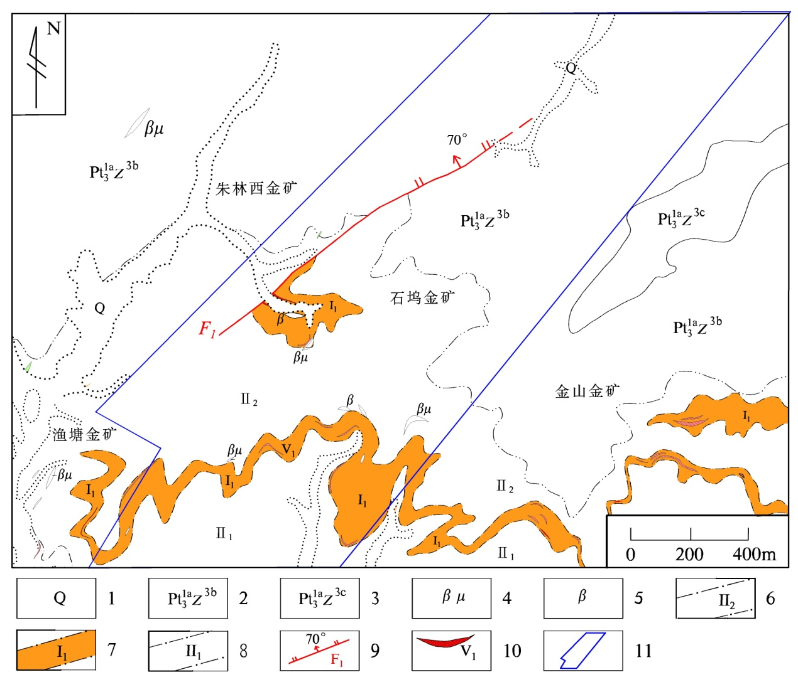
图1 石坞金矿区地质略图
Fig.1 Simplified geological map of Shiwu gold deposit
1-第四系；2-新元古界张村岩组上段第二亚段；3-新元古界张村岩组上段第三亚段；4-辉绿岩；5-变余安山玄武岩；6-初糜棱岩-石英、绢云母、白云石化带界线及代号；7-金山—朱林剪切带(石坞段)超糜棱岩、糜棱岩—石英、黄铁矿、铁白云石化、金矿化带界线及代号；8-千糜岩岩石-绿泥石、方解石、绢云母化带及代号；9-正断层及编号；10-金矿体及编号；11-矿权界线
矿区出露地层主要为新元古界张村岩组上段第二亚段（Pt₃^{1a}Z^{3b}）（图1），该地层为一套浅变质的火山碎屑沉积岩夹基性火山熔岩，岩性由砂质千枚岩、绿泥绢云千枚岩、凝灰质千枚岩、变余安山玄武岩等组成。矿区构造活以韧性剪切构造为主，为金山-朱林韧性剪切带的自然西延部分（石坞段）。此外，矿区内还见有轴向NE的石碑-西源岭背斜及沿背斜轴部产出的陡倾斜断层。矿区岩浆岩活动微弱，以同构造期侵位为主，主要为辉石闪长岩和辉绿岩两种，呈岩瘤、岩脉沿断层和剪切带零星分布。

2矿床地质特征
矿体主要产于金山-朱林韧性剪切带（石坞段）中心的超糜棱岩、糜棱岩、千糜岩金矿化蚀变带中。矿体呈层状、似层状沿走向、倾向均呈舒缓波状延伸展布，局部具膨大缩小。受背斜构造的影响，东部矿体走向NW-SE，倾向NE，倾角较缓，平均倾角13°，西部矿体走向NE-SE，倾向NW，倾角明显变陡，平均倾角30°。矿石类型主要由超糜棱岩-糜棱岩型、千糜岩型组成，见少量石英脉型。矿石结构种类繁多，以超糜棱结构、糜棱结构、初糜棱结构、自形-半自形结构、它形粒状结构、压碎重结晶结构、碎裂结构为主，次为包含结构、固溶体分解结构等。矿石矿物成分简单，有用矿物仅自然金一种，主要金属矿物有黄铁矿，其次为毒砂、黄铜矿、闪锌矿、方铅矿等，自然银、辉银矿、黝铜矿、斑铜矿、铜蓝、白铁矿和针铁矿等矿物含量甚微。脉石矿物主要为石英，次为长石、绢云母、绿泥石、白云石和铁白云石，此外还有少量的方解石、白云母、冰长石、碳质、磷灰石、锆石、锐钛矿、绿帘石等。

3地球化学特征
本次工作采取围岩和矿石样品共计16件，分析测试工作由江西有色地质测试研究院完成，其主量、微量及岩石稀土元素分析结果及特征值如表1所示。

3.1 主量元素
矿区主量元素从围岩千枚岩→含矿千糜岩→糜棱岩→超糜棱岩，SiO₂的含量逐渐增高，TFeO、Al₂O₃、TiO₂、MgO、Na₂O、K₂O、P₂O₅等含量逐渐降低，而CaO、MnO的含量变化并不明显，说明围岩千枚岩更接近原岩的组分。在成矿作用的过程中，SiO₂为带入组分，FeO、Al₂O₃、TiO₂、MgO、Na₂O、K₂O、P₂O₅等为带出组分，亦与矿区内强硅化现象相吻合。

3.2 微量元素
由矿区围岩千枚岩→含矿千糜岩→糜棱岩→超糜棱岩，微量元素含量呈降低趋势，在微量元素蛛网图中（图2），均显示出富集高场强元素Th、U、La、Ce、Zr、Hf，亏损大离子亲石元素Sr、Ba等特点，此与金山金矿田内含金岩石的微量元素特征相似。
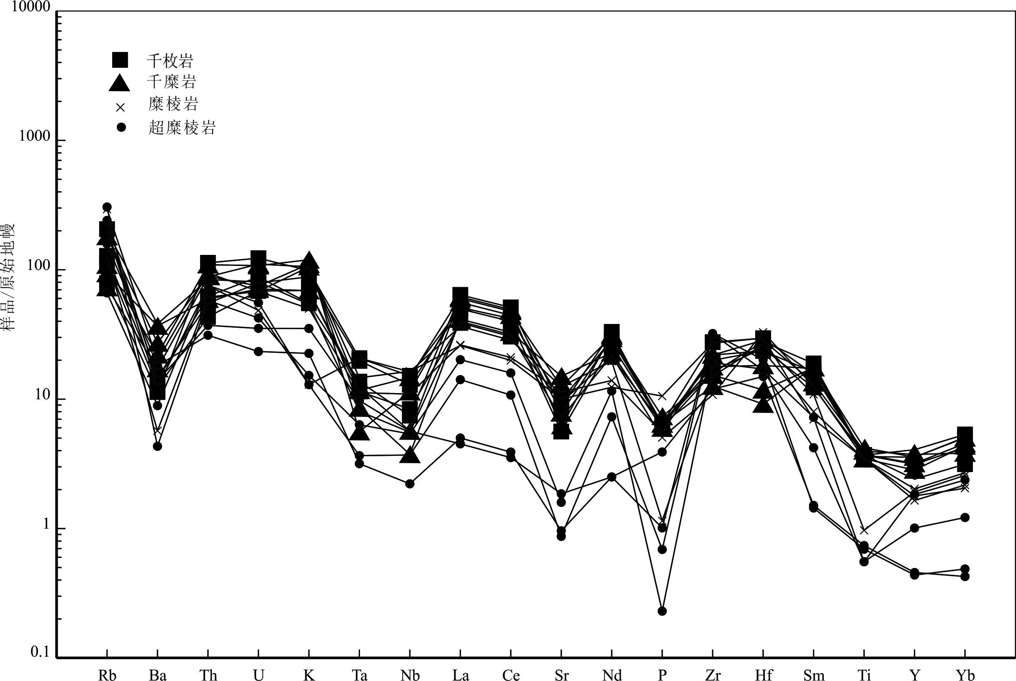
图2 石坞矿区不同岩性微量元素蛛网图
Fig.2 Spidergram of the rocks from Shiwu gold deposit

3.3 稀土元素
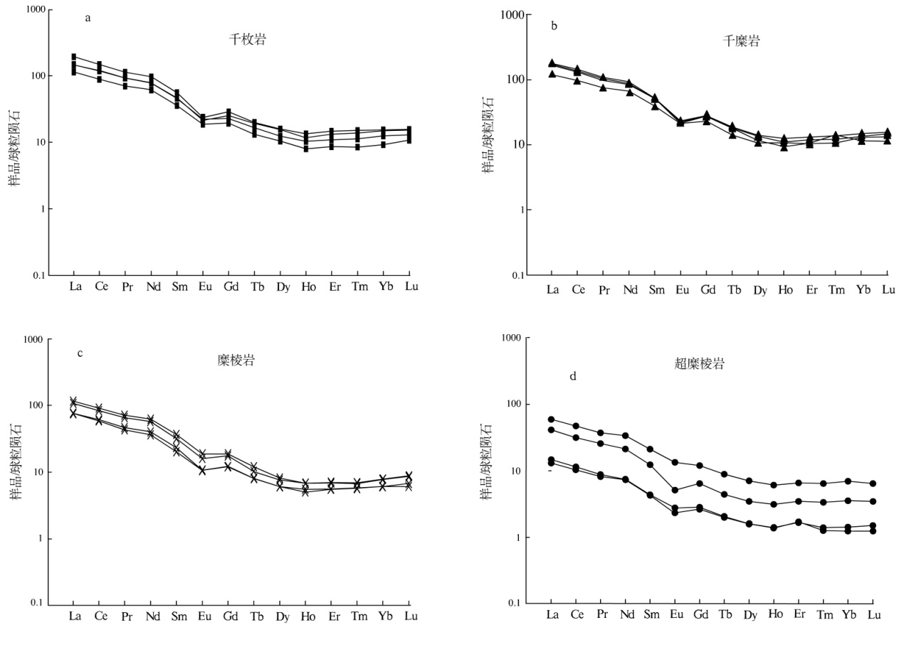
矿区围岩千枚岩的稀土元素总量较低，∑REE介于133.485～216.15×10⁻⁶之间，LREE介于122.55～165.65×10⁻⁶之间，HREE介于10.93～16.40×10⁻⁶之间。稀土元素球粒陨石标准化曲线呈右倾型（图3a），且轻重稀土元素分馏较为明显，（La/Yb)_{N}介于9.59～12.63之间，（La/Sm)_{N}介于3.15～3.39之间，（Gd/Yb)_{N}介于1.63～2.11之间；δEu值介于0.56～0.67之间，显示具较明显的Eu负异常。
图3 石坞矿区不同岩性稀土元素配分曲线（球粒陨石数据源于文献[3]）
Fig.3 REE pattern of the rocks from Shiwu gold deposit
含矿千糜岩的稀土元素总量较低，∑REE介于144.55～206.10×10⁻⁶之间，LREE介于131.93～191.81×10⁻⁶之间，HREE介于12.62～15.96×10⁻⁶之间。稀土元素球粒陨石标准化曲线呈右倾型（图3b），且轻重稀土元素分馏较为明显，（La/Yb)_{N}介于10.83～14.16之间，（La/Sm)_{N}介于3.10～3.47之间，（Gd/Yb)_{N}介于1.90～2.17之间；δEu值介于0.53～0.65之间，显示具较明显的Eu负异常。
含矿糜棱岩的稀土元素总量较低，∑REE介于84.41～135.57×10⁻⁶之间，LREE介于77.63～125.92×10⁻⁶之间，HREE介于6.78～9.65×10⁻⁶之间。稀土元素球粒陨石标准化曲线呈右倾型（图3c），且轻重稀土元素分馏较为明显，（La/Yb)_{N}介于11.92～14.73之间，（La/Sm)_{N}介于3.18～3.71之间，（Gd/Yb)_{N}介于1.87～2.40之间；δEu值介于0.63～0.67之间，显示具较明显的Eu负异常。
含矿超糜棱岩的稀土元素总量较低，∑REE介于16～72.72×10⁻⁶之间，LREE介于14.32～65.30×10⁻⁶之间，HREE介于1.67～7.42×10⁻⁶之间。稀土元素球粒陨石标准化曲线呈右倾型（图3d），且轻重稀土元素分馏较为明显，（La/Yb)_{N}介于8.53～11.64之间，（La/Sm)_{N}介于2.79～3.45之间，（Gd/Yb)_{N}介于1.73～2.35之间；δEu值介于0.55～0.81之间，显示具较明显的Eu负异常。

表1 石坞金矿主量元素(×10⁻²)、微量和稀土元素含量(×10⁻⁶)及特征值
Table 1. Major elements、trace element and rare earth element contents and feature of the rocks from Shiwu gold deposit
样品  元素 | 千枚岩 | 千枚岩 | 千枚岩 | 千枚岩 | 千糜岩 | 千糜岩 | 千糜岩 | 千糜岩 | 糜棱岩 | 糜棱岩 | 糜棱岩 | 糜棱岩 | 超糜棱岩 | 超糜棱岩 | 超糜棱岩 | 超糜棱岩
SiO₂ | 63.18 | 65.46 | 64.12 | 62.88 | 66.92 | 61.48 | 63.16 | 58.9 | 61.8 | 60.4 | 56.9 | 74.72 | 78.22 | 85.5 | 87.46 | 87.52
Al₂O₃ | 14.1 | 13.85 | 14.87 | 13.72 | 13.98 | 14.1 | 15.12 | 17.15 | 12.83 | 16.9 | 10.86 | 4.19 | 4.96 | 3.43 | 2.22 | 2.92
Fe₂O₃ | 0.86 | 0.86 | 1.25 | 0.9 | 0.86 | 0.83 | 1.04 | 1.22 | 0.89 | 1.01 | 0.64 | 0.33 | 0.3 | 0.32 | 0.33 | 0.33
FeO | 5.04 | 4.86 | 4.51 | 5.6 | 5.18 | 4.89 | 5.86 | 6.47 | 5.57 | 5.79 | 6.16 | 2.7 | 1.83 | 2.03 | 1.54 | 1.48
TiO₂ | 0.8 | 0.78 | 0.8 | 0.8 | 0.75 | 0.81 | 0.86 | 0.91 | 0.75 | 0.75 | 0.75 | 0.21 | 0.15 | 0.16 | 0.12 | 0.12
CaO | 1.64 | 1.74 | 1.05 | 2.44 | 0.91 | 1.74 | 1.4 | 1.74 | 3.35 | 1.12 | 5.02 | 4.88 | 2.72 | 0.35 | 2.37 | 1.26
MgO | 1.98 | 1.7 | 1.75 | 2.76 | 1.6 | 1.86 | 1.75 | 2.11 | 3.36 | 2.06 | 4.21 | 1.96 | 1.55 | 0.65 | 0.62 | 0.8
MnO | 0.1 | 0.09 | 0.09 | 0.14 | 0.11 | 0.16 | 0.14 | 0.16 | 0.12 | 0.14 | 0.19 | 0.18 | 0.13 | 0.12 | 0.14 | 0.1
K₂O | 2.66 | 1.66 | 2.08 | 2.97 | 3.18 | 2.08 | 3.33 | 3.6 | 1.63 | 3.17 | 1.51 | 0.39 | 0.68 | 1.06 | 0.46 | 0.39
Na₂O | 2.84 | 2.57 | 2.33 | 0.81 | 0.67 | 3.03 | 0.25 | 1.03 | 2.31 | 2.33 | 1.19 | 0.53 | 1.2 | 0.22 | 0.32 | 0.8
P₂O₅ | 0.14 | 0.13 | 0.14 | 0.14 | 0.14 | 0.14 | 0.13 | 0.16 | 0.11 | 0.23 | 0.12 | 0.025 | 0.022 | 0.085 | 0.005 | 0.015
LOI | 6.27 | 4.66 | 5.33 | 6.82 | 4.99 | 7.3 | 6.62 | 6.56 | 6.18 | 5.29 | 10.03 | 8.17 | 6.64 | 3.8 | 4.07 | 2.79
TOTAL | 99.61 | 98.36 | 98.32 | 99.98 | 99.29 | 98.42 | 99.66 | 100.01 | 98.9 | 99.19 | 97.58 | 98.285 | 98.402 | 97.725 | 99.655 | 98.525
La | 34.19 | 43.94 | 26.67 | 35.09 | 42.37 | 41.07 | 28.52 | 38.45 | 27.39 | 17.84 | 18.03 | 25.09 | 3.44 | 3.1 | 13.87 | 9.72
Ce | 70.86 | 90.85 | 54.05 | 74.48 | 87.27 | 84.69 | 58.32 | 78.94 | 55.84 | 35.37 | 37.32 | 50.65 | 6.92 | 6.27 | 28.28 | 19.1
Pr | 8.36 | 10.5 | 6.54 | 8.71 | 10.15 | 9.88 | 7.05 | 9.26 | 6.77 | 4 | 4.43 | 6.14 | 0.82 | 0.76 | 3.52 | 2.39
Nd | 35.4 | 44.83 | 28.74 | 38.95 | 42.79 | 41.68 | 30.95 | 40 | 29.29 | 16.73 | 18.87 | 26.57 | 3.39 | 3.39 | 15.65 | 9.89
Sm | 6.92 | 8.38 | 5.47 | 7.19 | 7.89 | 7.65 | 5.94 | 7.75 | 5.57 | 3.1 | 3.55 | 4.84 | 0.64 | 0.67 | 3.21 | 1.87
Eu | 1.25 | 1.34 | 1.07 | 1.23 | 1.33 | 1.27 | 1.17 | 1.21 | 1.06 | 0.59 | 0.63 | 0.9 | 0.16 | 0.13 | 0.77 | 0.3
Gd | 4.8 | 5.77 | 3.97 | 5.16 | 5.63 | 5.51 | 4.66 | 5.71 | 3.87 | 2.42 | 2.49 | 3.54 | 0.54 | 0.59 | 2.44 | 1.3
Tb | 0.61 | 0.7 | 0.48 | 0.73 | 0.67 | 0.65 | 0.52 | 0.69 | 0.44 | 0.31 | 0.28 | 0.37 | 0.07 | 0.08 | 0.33 | 0.16
Dy | 3.05 | 3.83 | 2.58 | 3.99 | 2.96 | 3.31 | 2.66 | 3.53 | 2.06 | 1.5 | 1.53 | 1.91 | 0.39 | 0.41 | 1.76 | 0.87
Ho | 0.56 | 0.65 | 0.45 | 0.74 | 0.52 | 0.6 | 0.58 | 0.7 | 0.38 | 0.28 | 0.31 | 0.37 | 0.08 | 0.08 | 0.34 | 0.17
Er | 1.78 | 2.15 | 1.42 | 2.39 | 1.75 | 1.94 | 1.66 | 2.13 | 1.17 | 0.88 | 0.95 | 1.08 | 0.28 | 0.27 | 1.06 | 0.57
Tm | 0.28 | 0.35 | 0.21 | 0.37 | 0.27 | 0.3 | 0.35 | 0.33 | 0.18 | 0.14 | 0.15 | 0.16 | 0.04 | 0.03 | 0.16 | 0.08
Yb | 2.09 | 2.5 | 1.55 | 2.63 | 2.15 | 2.24 | 1.89 | 2.48 | 1.33 | 1.07 | 1.01 | 1.27 | 0.24 | 0.21 | 1.17 | 0.6
Lu | 0.33 | 0.38 | 0.27 | 0.39 | 0.35 | 0.37 | 0.29 | 0.38 | 0.22 | 0.17 | 0.15 | 0.21 | 0.04 | 0.03 | 0.16 | 0.09
∑REE | 170.48 | 216.15 | 133.48 | 182.05 | 206.1 | 201.18 | 144.55 | 191.59 | 135.57 | 84.41 | 89.7 | 123.1 | 17.04 | 16 | 72.72 | 47.11
LREE | 156.97 | 199.83 | 122.55 | 165.65 | 191.81 | 186.25 | 131.93 | 175.63 | 125.92 | 77.63 | 82.83 | 114.2 | 15.37 | 14.32 | 65.3 | 43.26
HREE | 13.51 | 16.32 | 10.93 | 16.4 | 14.29 | 14.93 | 12.62 | 15.96 | 9.65 | 6.78 | 6.87 | 8.9 | 1.67 | 1.68 | 7.42 | 3.85
LREE/HREE | 11.62 | 12.24 | 11.21 | 10.1 | 13.42 | 12.48 | 10.46 | 11 | 13.04 | 11.45 | 12.06 | 12.83 | 9.23 | 8.51 | 8.8 | 11.24
（La/Yb）_{N} | 11.76 | 12.63 | 12.32 | 9.59 | 14.16 | 13.16 | 10.83 | 11.11 | 14.73 | 11.92 | 12.85 | 14.23 | 10.37 | 10.77 | 8.53 | 11.64
（La/Sm）_{N} | 3.19 | 3.39 | 3.15 | 3.15 | 3.47 | 3.46 | 3.1 | 3.2 | 3.18 | 3.71 | 3.28 | 3.35 | 3.45 | 2.99 | 2.79 | 3.35
（Gd/Yb）_{N} | 1.91 | 1.91 | 2.11 | 1.63 | 2.17 | 2.04 | 2.04 | 1.9 | 2.4 | 1.87 | 2.04 | 2.31 | 1.88 | 2.35 | 1.73 | 1.79
δEu | 0.63 | 0.56 | 0.67 | 0.59 | 0.58 | 0.57 | 0.65 | 0.53 | 0.67 | 0.63 | 0.62 | 0.64 | 0.8 | 0.64 | 0.81 | 0.55
Li | 19.38 | 2.78 | 25.36 | 6.15 | 31.65 | 19.13 | 41.18 | 13.21 | 12.18 | 38.58 | 25.34 | 51.63 | 10.1 | 24.69 | 59.17 | 50.3
Sc | 4.67 | 3.4 | 7 | 4.42 | 3.67 | 2.22 | 7.95 | 2.78 | 7.14 | 7.67 | 8.87 | 8.2 | 3.41 | 9.49 | 9.17 | 3.68
V | 173.61 | 136.03 | 89.83 | 103.95 | 167.82 | 66.65 | 93.75 | 43.91 | 49.15 | 122.29 | 136.54 | 112.88 | 24.72 | 60.44 | 52.03 | 72.83
Cr | 13.08 | 10.52 | 21.2 | 7.7 | 27.24 | 22.86 | 17.55 | 4.05 | 22.49 | 13.97 | 23.47 | 11.94 | 6.93 | 25.8 | 14.09 | 19.07
Co | 14.06 | 29.14 | 10.87 | 25.28 | 19.02 | 8.78 | 4.17 | 26.42 | 24.22 | 11.79 | 6.71 | 5.9 | 28.53 | 19.97 | 14.71 | 2.49
Ni | 30.01 | 29.89 | 14.25 | 11.75 | 32.68 | 27.31 | 33.5 | 26.19 | 15.96 | 37.88 | 11.33 | 28.3 | 10.11 | 18.66 | 17.2 | 34.94
Cu | 30.11 | 15.09 | 27.78 | 23.39 | 3.27 | 33.89 | 39.43 | 6.09 | 29.91 | 38.88 | 26.49 | 11.85 | 19.62 | 4.19 | 6.31 | 18.52
Zn | 62.92 | 73.27 | 63.58 | 89.65 | 47.98 | 71.11 | 36.56 | 62.18 | 72.39 | 54.61 | 47.04 | 34.34 | 88.07 | 79.83 | 51.73 | 64.68
Ga | 16.35 | 22.05 | 2.12 | 26.52 | 29.25 | 12.4 | 29.19 | 28.34 | 10.09 | 8.74 | 15.19 | 2.17 | 19.91 | 15.07 | 5.73 | 23.91
Rb | 130.79 | 81.29 | 72.15 | 50.12 | 46.29 | 59.14 | 114.83 | 68.86 | 125.04 | 80.01 | 186.8 | 127.99 | 100.65 | 152.74 | 194.03 | 42.05
Sr | 118.62 | 183.37 | 198.95 | 208.13 | 129.06 | 262.63 | 317.04 | 165.06 | 150.91 | 211.43 | 239.56 | 264.03 | 20.26 | 39.18 | 33.61 | 18.35
Y | 14.28 | 16.19 | 10.95 | 18.5 | 12.89 | 14.48 | 17 | 16.2 | 9.21 | 7.5 | 8.13 | 8.73 | 1.99 | 2.08 | 8.35 | 4.59
Nb | 9.21 | 5.32 | 5.98 | 10.8 | 10.5 | 4.04 | 2.67 | 8.14 | 3.96 | 11.69 | 7.8 | 11.6 | 1.58 | 4.03 | 3.84 | 2.64
Zr | 308.97 | 178.53 | 186.78 | 223.61 | 141.1 | 199.58 | 245.34 | 171.68 | 121.18 | 303.37 | 245.37 | 168.9 | 360.18 | 133.85 | 213.9 | 356.71
Ba | 103.14 | 98.33 | 86.21 | 79.3 | 120.52 | 256.81 | 190 | 153.95 | 266.45 | 39.79 | 138.81 | 86.69 | 126.62 | 97.05 | 30.22 | 62.29
Hf | 9.14 | 8.58 | 7.59 | 7.29 | 2.83 | 5.63 | 8.82 | 3.64 | 10.15 | 9.16 | 7.3 | 8.16 | 6.23 | 4.62 | 5.28 | 5.17
Ta | 0.81 | 0.56 | 0.47 | 0.85 | 0.48 | 0.51 | 0.35 | 0.23 | 0.33 | 0.6 | 0.46 | 0.85 | 0.13 | 0.4 | 0.26 | 0.15
Pb | 16.32 | 15 | 14.57 | 1.94 | 3.3 | 5.19 | 9.1 | 15.94 | 3.57 | 3.21 | 15.15 | 6.03 | 11.38 | 2.55 | 15.44 | 2.53
Th | 4.68 | 5.31 | 3.68 | 9.62 | 7.5 | 5.04 | 7.59 | 9.3 | 7.15 | 5.22 | 8.04 | 6.38 | 2.65 | 3.16 | 4.92 | 6.44
U | 1.66 | 1.85 | 1.44 | 2.58 | 2.32 | 1.49 | 1.57 | 2.26 | 1.69 | 1.43 | 1.43 | 1.02 | 0.49 | 0.74 | 0.89 | 1.17
K | 22072 | 13774 | 17260 | 24645 | 26387 | 17260 | 27632 | 29872 | 13526 | 26304 | 12530 | 3236 | 5643 | 8796 | 3817 | 3236
P | 611 | 568 | 611 | 611 | 611 | 611 | 568 | 699 | 480 | 1004 | 524 | 109 | 96 | 371 | 22 | 65
Ti | 4800 | 4680 | 4800 | 4800 | 4500 | 4860 | 5160 | 5460 | 4500 | 4500 | 4500 | 1260 | 900 | 960 | 720 | 720

4讨论

4.1成矿物质来源
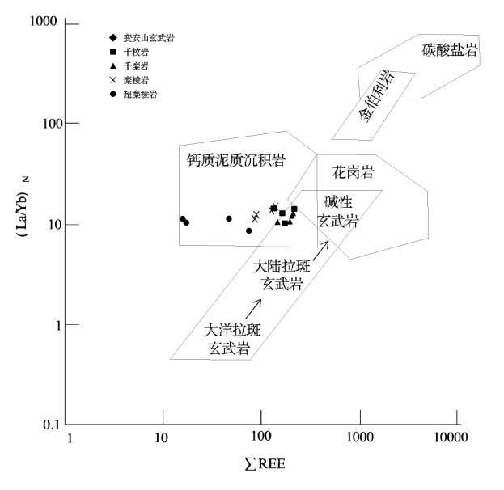
新元古界张村岩组为区域含金矿源层^{[13]}，从稀土元素特征可知，矿区岩石的稀土元素配分曲线均呈右倾型，具弱Eu的负异常，由千枚岩→千糜岩→糜棱岩→超糜棱岩，随岩石蚀变、变形作用的加强，稀土元素总量∑REE呈现递减的趋势，且具有平行下移的特征。稀土元素常易于在碱性环境下形成络阴离子，与碳酸盐、硫酸盐和氟化物等结合形成络合物，随流体发生迁移。金山金矿田成矿流体为弱酸性-碱性 ^{[4-5、15-21]}，有利于稀土元素的活化、迁移，故而随着蚀变程度的加强，∑REE递减，且超糜棱岩中见强烈的碳酸盐化，亦解释了超糜棱岩中∑REE的剧烈减少。稀土配分曲线具有平行下移的特征，此说明含矿岩石与围岩具有一定的继承性，且应具有相同的流体来源及一定的成因联系。上述稀土元素特征与金山金矿田内的金山金矿^{[6-10]}、朱林西金矿^{[11]}以及双桥山群^{[12]}（现定名为张村岩组）的稀土元素特征相似，说明石坞金矿区与金山金矿、朱林西金矿具有相同的成矿流体均来源于新元古界张村岩组，且该组地层在德兴地区具有相对较高的Au元素丰度值^{[12-13]}，为金矿成矿提供了丰富的物源。
图4 石坞金矿不同岩性(La/Yb)_{N}-∑REE图解（据文献[14]修）
Fig.4 (La/Yb)_{N}-∑REE diagram of the rocks from Shiwu gold deposit
在(La/Yb)_{N}-∑REE岩石成因分类判别图解中（图4），千枚岩全部落入钙质泥质沉积岩与大陆拉斑玄武岩的叠加区域，千糜岩两个样品落入钙质泥质沉积岩与大陆拉斑玄武岩的叠加区域，两个样品落入钙质泥质沉积岩区，糜棱岩、超糜棱岩均落入钙质泥质沉积岩区，说明石坞金矿物源的原岩应为富集火山物质的火山沉积岩系，而矿区内出露的变安山玄武岩（数据未发表）以及金山金矿田内出露的镁铁质岩石，均形成于岛弧拉张环境下，证实了石坞矿区中-新元古代存在岛弧火山活动，为新元古界张村岩组火山泥砂质浊积岩的形成提供了丰富的物质基础。

4.2形成机制
晋宁运动早期，由于前寒武纪克拉通的裂解，华南洋的形成，致使华夏古陆从扬子古陆分离，形成扬子古板块和华夏古板块，此时，石坞金矿区处于扬子古板块的南缘；随着华南洋的形成，华南洋沿萍乡-广丰深大断裂一线由北向南俯冲至华夏古板块之下，使矿区处于大洋岛弧大地构造背景之下，海相火山喷发，并沉积，形成富含火山物质的沉积建造，即为Au元素的初始聚集阶段；随着晋宁运动的发展，华南洋沿宜丰-景德镇深大断裂由南向北俯冲至扬子古板块之下，并消亡，致使扬子板块与华夏板块最终碰撞拼合，期间矿区遭受强烈的褶皱、变形作用，使基底地层发生区域变质和韧性变形作用，即为Au元素进一步富集阶段；加里东运动强烈的逆冲推覆作用使矿区内地层遭受强烈的韧性变形作用，主要表现为韧性剪切变形带以及塑性变形的产生，该期亦是主成矿期，岩石在“变形分解+液体致裂+构造泵吸”^{[23]}的联合作用下，形成含Au的变质流体，于富Na⁺、K⁺的热液中迁移，在弱酸-碱性、较为还原以及中-低温压的环境下分离沉淀出来，从而形成韧性剪切带强应变中心的金矿体。

5结论
（1）石坞矿区岩石由千枚岩、千糜岩、糜棱岩到超糜棱岩，SiO₂为带入组分，Al₂O₃、TiO₂、MgO、Na₂O、K₂O、P₂O₅为带出组分；微量元素显示出富集高场强元素Th、U、La、Ce、Zr、Hf，亏损大离子亲石元素Sr、Ba等特点；稀土元素配分曲线均呈右倾型，具明显Eu的负异常的特征，与金山金矿、朱林西金矿稀土元素特征相似。
（2）石坞矿区由千枚岩→千糜岩→糜棱岩→超糜棱岩，其主量、微量和稀土元素均具有相似的地球化学特征，表明了石坞矿区围岩与矿体具有相同的物质来源，应源于新元古界张村岩组，该时期应处于岛弧拉张的背景。

参考文献
[1]李传明，陈小惠.江西石坞金矿成矿特征及找矿方向[J].地质与勘探，2005，41(4):10-17.
LI Chuanming, CHEN Xiaohui. Metallogenic characteristic and ore prospecting direction of Shiwu deposit, Jiangxi[J].Geology and prospecting, 2005, 41(4):10-17.
[2]《中国矿产地质志·江西卷》编撰委员会.中国矿产地质志·江西卷[R].地质出版社，2015.
The Editorial committee of 《The mineral geological records of China-Volume of Jiangxi province》[R]. Geology Press, 2015.
[3]SUN Shensu. and McDonough W. F. Chemical and Isotopic Systematic of Oceanic Basalts: Implications for Mantle Composition and Processes[J]. Geological Society, London, Special Publications, 1989, 42(1): 313-345.
[4]刘志远，金成洙，王荣湖等.江西金山金矿成矿流体地球化学及矿床成因讨论[J].地质找矿论丛，2005，20 (2):93-99.
LIU Zhiyuan, JIN Chengzhu, WANG Ronghu, et al. Ore fluid geochemistry and the discussion on ore genesis of Jinshan gold deposit, Jiangxi Province[J]. Contributions to Geology and Mineral Resources Research, 2005, 20 (2):93-99.
[5]肖光富，唐一昂，卢树东等.江西朱林西金矿流体包裹体特征及成矿流体来源研究 [J].黄金地质，2020，44(1):20-29.
XIAO Guangfu, TANG Yiang, LU Shudong, et al. Research on characteristics of fluid inclusions and source of ore-forming fluids in Zhulinxi Gold deposit in Jiangxi Province[J]. Gold, 2020, 44(1):20-29.
[6]杨子江.金山韧性剪切带大型金矿床稀土元素地球化学[J].黄金地质，1997，3 (2):17-23.
YANG Zijiang. The geochemistry of rare earth elements of large gold deposit in Jinshan ductile shear zone[J].Gold, 1997, 3 (2):17-23.
[7]刘志远，金成洙，王荣湖等.江西金山金矿稀土元素地球化学特征及意义[J].地质与资源，2005，14 (1):12-17.
LIU Zhiyuan, JIN Chenzhu, WANG Ronghu, et al. Significance and geochemical characteristics of rare earth elements of Jinshan deposit, Jiangxi Province[J]. Geology and Resources, 2005, 14 (1):12-17.
[8]赵元芝，李小赛，吴德新等.江西德兴金山金矿晋宁期花岗质超糜棱岩的发现及意义[J].地质与勘探，2014，50(5): 805-822.
ZHAO Yuanzhi, LI Xiaosai, WU Dexing, et al. Discovery of Jinningian Granitic Ultramylonite in Jinshan Gold Deposit，Dexing Area，Jiangxi Province and its Significance[J].Geology and Exploration, 2014, 50(5): 805-822.
[9]李晓峰，易先奎，朱和平.德兴金山金矿床成矿流体来源: 小尺度构造和同位素地球化学证据[J]．矿床地质，2009，28( 1) : 42-52．
LI Xiaofeng, YI Xiankui, ZHU Heping. Source of ore-forming fluids in Jinshan gold deposit of Dexing County: Constrains from microstructures and stable isotopes[J]. Mineral Geology, 2009, 28( 1) : 42-52．
[10]吴德新.江西德兴矿集区成岩成矿作用研究[D].中国地质大学（北京），2013.
WU Dexing. A study on genesis and mineralization of Dexing ore area of Jiangxi Province[D]. China University of Geosciences(Beijing), 2013.
[11]张开平，赵辉，卢树东等.江西金山金矿田朱林西-竹叶岭矿区岩石地球化学特征及矿床成因探讨[J].黄金地质，2017，38 (10):10-18.
ZHANG Kaiping, ZHAO Hui, LU Shudong, et al. Litho-geochemical characteristics of Zhulinxi-Zhuyeling district in Jinshan Gold Field of Jiangxi Province and its genesis[J]. Gold, 2017, 38 (10):10-18.
[12]刘英俊，沙鹏，朱恺军等.江西德兴地区中元古界双桥山群含金建造的地球化学研究[J].桂林冶金地质学院学报，1989，9 (2):115-126.
LIU Yingjun, SHA Peng, ZHU Kaijun, et al. The study on geochemistry of the gold-bearing formation of middle Proterozoic Shuangqiaoshan Group in Dexing district, Jiangxi[J]. Journal of Guilin college of geology, 1989, 9 (2):115-126.
[13]江西有色地质研究所. 德兴—乐平成矿带成矿规律成矿预测研究报告[M].1989.
Jiangxi Nonferrous metal Geological Research Institute. Research Report on Metallogenic Law of Dexing-Leping Metallogenic Belt[M].1989.
[14]Allegre C.J. and Minster J.F. Quantitative models of trace element behavior in magmatic processes [J].Earth & Planetary Science Letters, 1978, 38(1):1-25.
[15]黄宏立，杨文思.赣东北金山金矿的地质特征及矿床成因[J].地质找矿论丛，1990，5(2):29-39.
HUANG Hongli, YANG Wensi. Geological characteristics and genesis of Jinshan gold deposit in the northeastern Jiangxi Province[J]. Contributions to Geology and Mineral Resources Research, 1990, 5(2):29-39.
[16]曾键年，林卫兵，范永香.江西金山金矿成矿地球化学特征 [J].地质地球化学，2002，30(4):26-33.
ZENG Jiannian, LIN Weibin, FAN Yongxiang. A study of metallogeno-geochemical characteristics of Jinshan gold deposit, Jiangxi Province[J]. Geology-Geochemistry, 2002, 30(4):26-33.
[17]华仁民，李晓峰，张开平等.江西金山金矿成矿过程流体作用地球化学特征[J].南京大学学报（自然科学），2002，38(3):408-417.
HUA Renming, LI Xiaofeng, ZHANG Kaiping, et al. Geochemical Features of Ore-forming Fluid in the Jinshan Gold Deposit, Jiangxi Province[J]. Journal of Nanjing University (Natural Sciences), 2002, 38(3):408-417.
[18]季峻峰，孙承辕，郑晴.江西金山剪切带型金矿床中含金石英脉的成矿特征[J].地质论评，1994，40(4) :361-367.
JI Junfeng, SUN Chenyuan, ZHENG Qing. The metallogenetic characteristics of auriferous quartz veins in the Jinshan shear zone type gold deposit Jiangxi Province[J]. Geological review, 1994, 40(4):361-367.
[19]季峻峰，刘英俊，孙承辕等.江西金山剪切带型金矿两类矿石的地球化学特征-兼论两阶段成矿机制[J].地球化学，1994，23(3):226-234.
JI Junfeng, LIU Yingjun, SUN Chenyuan, et al. Chemical characteristics of two types of ores from Jinshan shear zone-hosted gold deposit, Jiangxi-with discussion on genesis of two-stage mineralization[J]. Geochemica, 1994, 23(3):226-234.
[20]范宏瑞，李兆麟.金山金矿矿床地质特征、成矿物理化学条件及成矿物质来源[J].地质科学，1992，增刊:147-160.
FAN Hongrui, LI Zhaolin. Geological characteristics, physic-chemical conditions and source materials for mineralization of the Jinshan gold deposit[J]. Scienta Geologica Sinica, 1992, Extra edition: 147-160.
[21]王可勇，梁敏鎏，卢作祥.江西金山金矿矿床地质特征及矿床成因探讨[J]．地质与勘探，1999，35( 2) : 17-20．
WANG Keyong, LIANG Minliu, LU Zuoxiang. Geology and origin of the Jinshan deposit in Jiangxi Province and discussion on its genesis[J]. Geology and Prospecting, 1999,35( 2) : 17-20．
[22]汪劲草，李帅，余何等.韧性剪切带型金矿三阶段构造成矿模式-以广东河台金矿床为例 [J].大地构造与成矿学，2020，44(1):20-29.
WANG Jincao, LI Shuai, YU He, et al. Three-stage structural mineralization model for ductile shear zone related gold deposits: A case study of the Hetai gold deposit, Guangdong, South China[J]. Geotectonica et Metallogenia, 2020, 44(1):20-29.

基金项目：中国地质调查局老矿山深部和外围找矿项目（编号：1212011220692）；江西有色地质勘查局（赣色勘地矿字[2020]25号） 作者简介：曾庆友，男，1988年生，本科，高级工程师，从事地质矿产勘查工作。Email：34380223@qq.com

